Creating a Springboot App

Open <https://start.spring.io/>

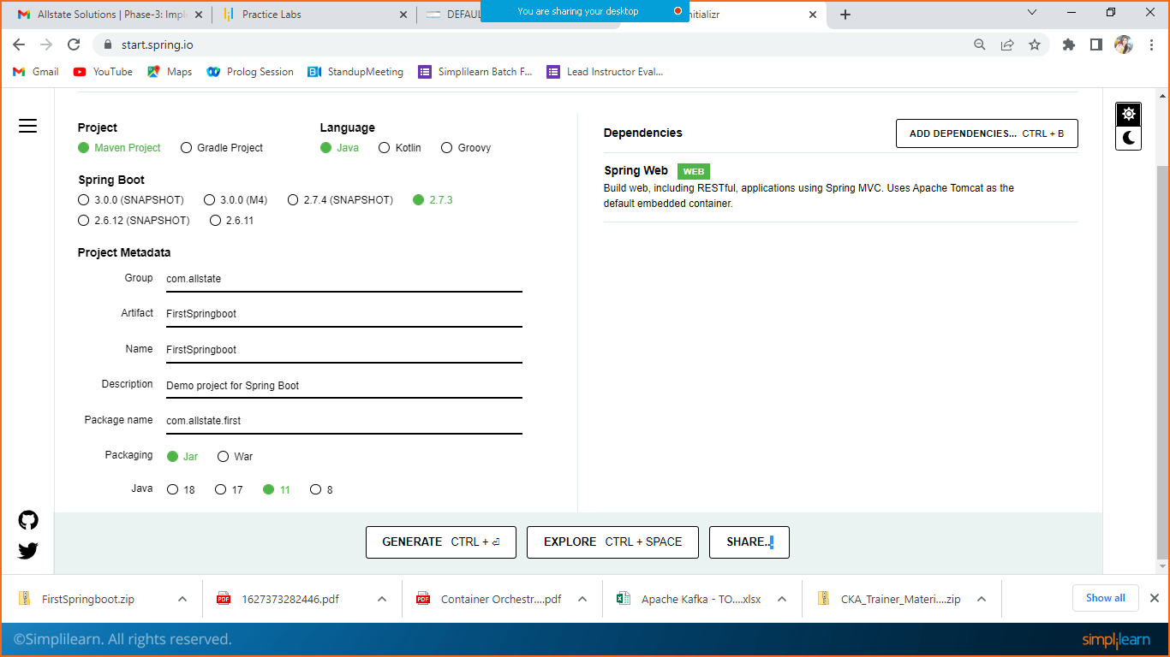

Click on generate, so it will download the zip file to your system, extract the project.

In eclipse inport the project.

File > import > maven > Existing Maven project> browse your project> select and import.

Once imported successfully.

You can check the main method which is the execution point of your application.

Let’s create one controller.

package com.allstate.first;

import org.springframework.web.bind.annotation.RequestMapping;

import org.springframework.web.bind.annotation.RestController;

@RestController

public class MainController {

@RequestMapping("/hello")

public String hello() {

return "Welcome from my springboot app";

}

}

Let’ change port number.

Open application.properties file

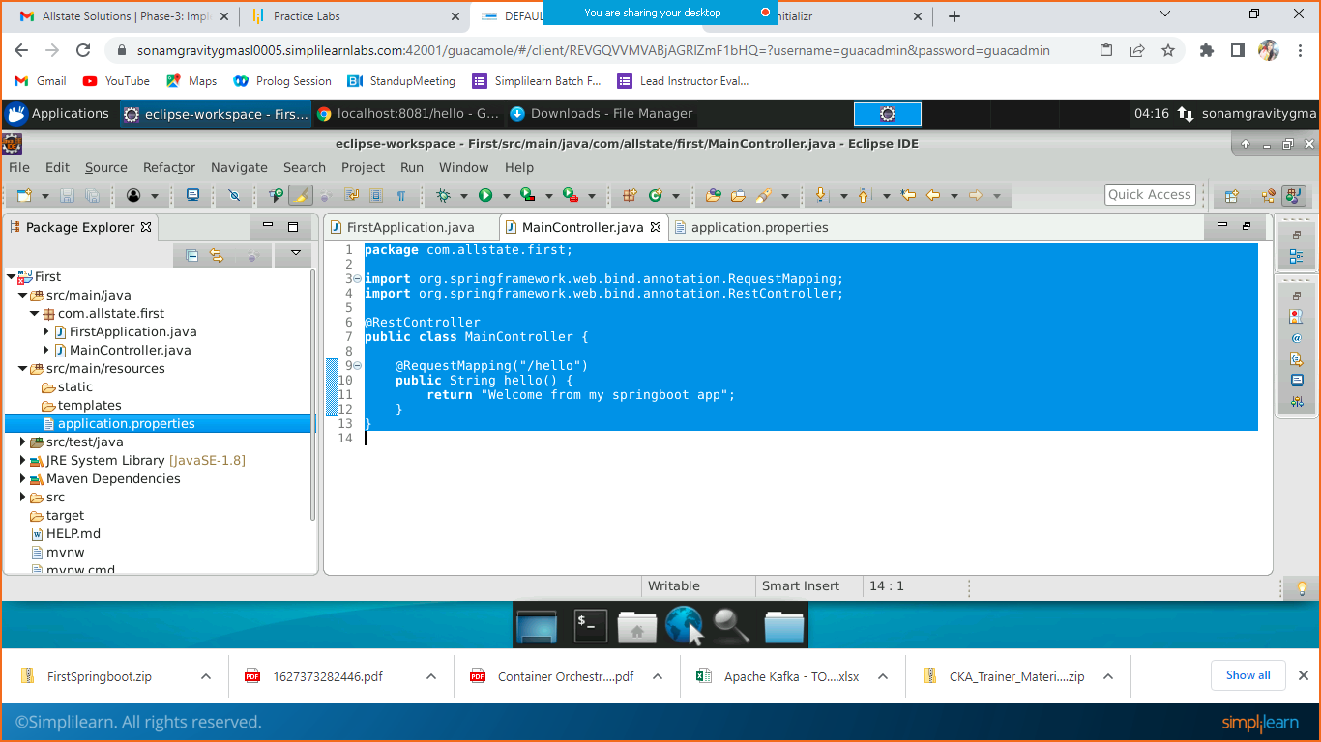

And add below property

server.port=8081

save.

Right click on your main method or project and run as JAVA application, which will run on embedded server.

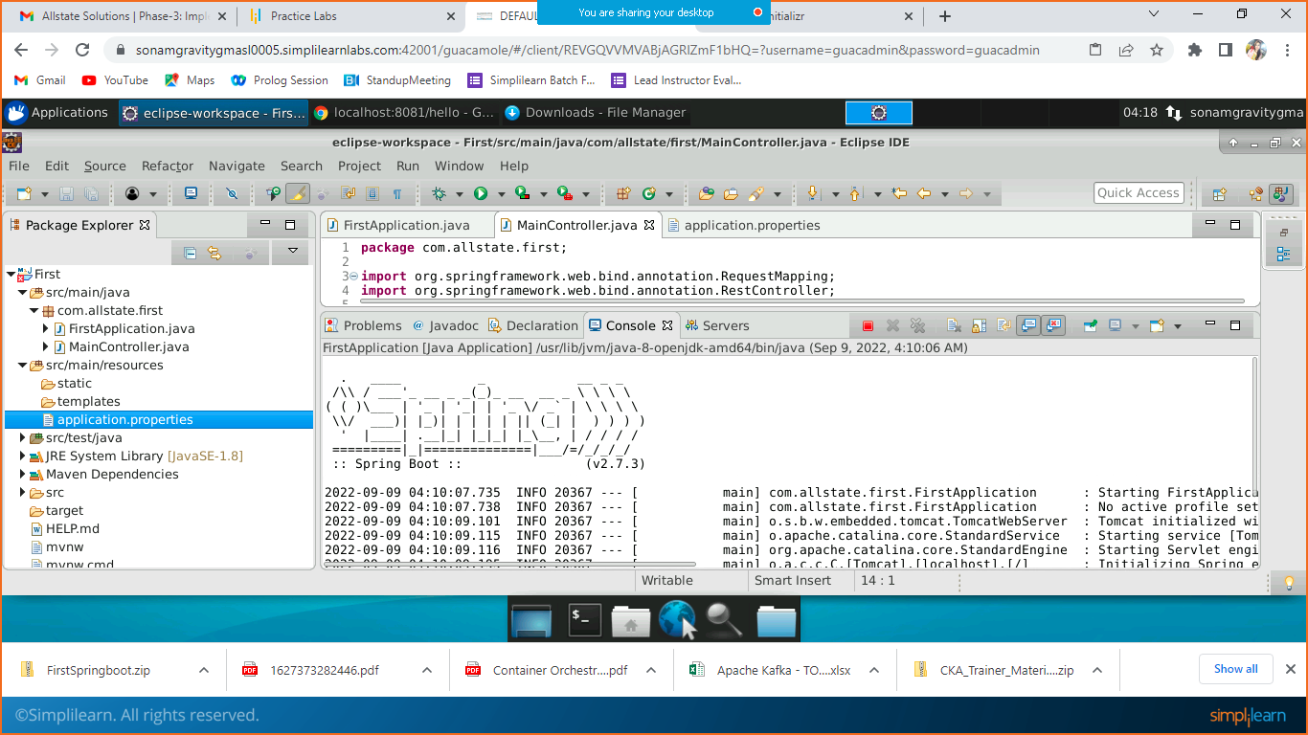

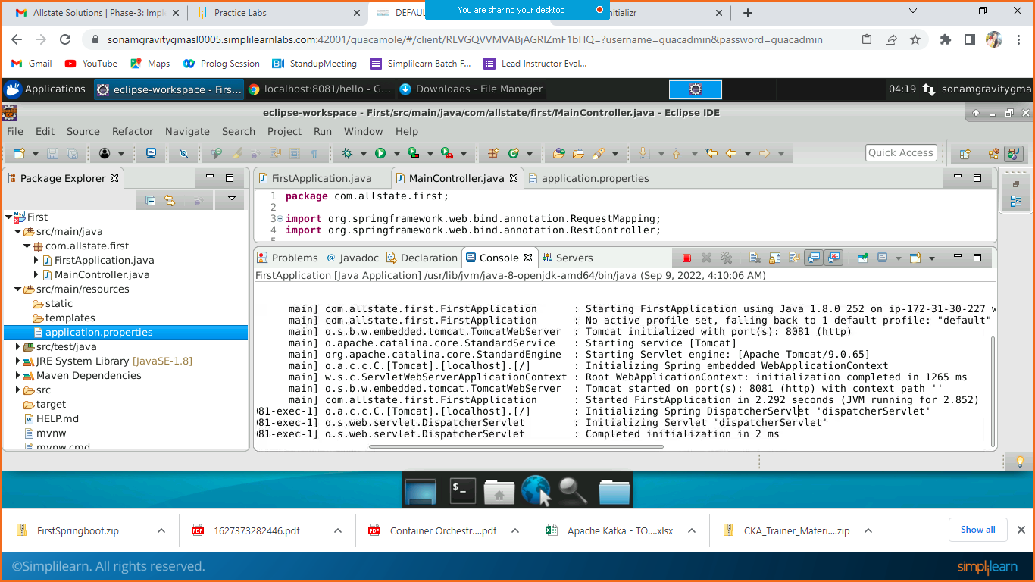

Now open the browser and check

Localhost:8081/hello

